Multivariate Regression
Code:
import pandas as pd
from sklearn.datasets import fetch_california_housing
from sklearn.model_selection import train_test_split
from sklearn.linear_model import LinearRegression
from sklearn.metrics import mean_squared_error, r2_score

data = fetch_california_housing(as_frame=True)
df = data.frame

df.columns = ['x3', 'x4', 'x5', 'x6', 'x7', 'x8', 'x9', 'x10', 'y']

df.head()

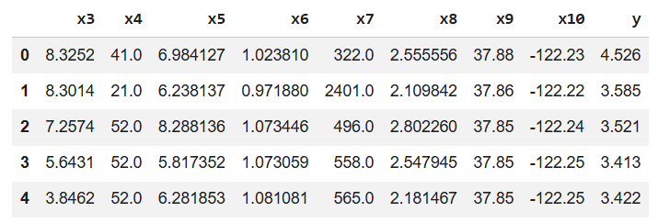

X = df[['x3', 'x4', 'x5', 'x6', 'x7', 'x8', 'x9', 'x10']]
Y = df['y']

df.head()
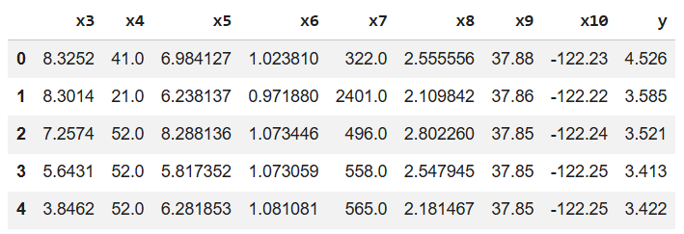

X_train, X_test, Y_train, Y_test = train_test_split(
X, Y, test_size=0.2, random_state=42
)

model = LinearRegression()
model.fit(X_train, Y_train)

Y_pred = model.predict(X_test)

print("Intercept:", model.intercept_)
print("Coefficients:")

for feature, coef in zip(X.columns, model.coef_):
print(f"{feature}: {coef:.4f}")

print("\nMean Squared Error:", mean_squared_error(Y_test, Y_pred))
print("R² Score:", r2_score(Y_test, Y_pred))

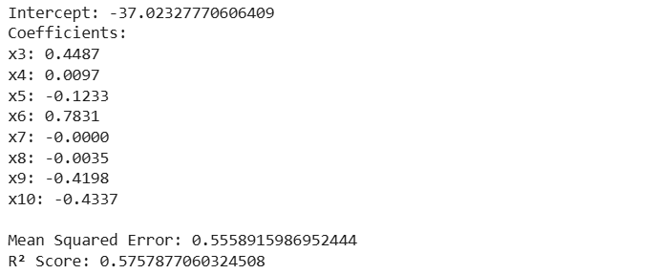

new_data = [[5.0, 25.0, 5.0, 1.0, 1.0, 2.0, 0.5, 0.2]]

prediction = model.predict(new_data)
print("\nPredicted Y value:", prediction[0])

import matplotlib.pyplot as plt
import seaborn as sns

plt.figure(figsize=(10, 7))

sns.scatterplot(x=Y_test, y=Y_pred, alpha=0.6)

plt.plot(
[Y_test.min(), Y_test.max()],
[Y_test.min(), Y_test.max()],
'r--',
lw=2
)

plt.xlabel('Actual Y Values')
plt.ylabel('Predicted Y Values')
plt.title('Actual vs. Predicted Y Values')
plt.grid(True, linestyle='--', alpha=0.7)

plt.show()

Output:
